Contents

How to set up project for Bookstore Project 2

Prerequisite 2

Overview 2

Before setting up 2

Flush dns cache in your computer 2

Clear Git credentials in your computer 3

Change git Configuration 4

Let get started setting up the project 4

Connect to CS AzureDevops server 4

Connect to CS AzureDevops Database 7

Setting Git on local machine 8

Additional Knowledge 9

How to set up Team Foundation Server 9

# How to set up project for Bookstore Project

## Prerequisite

Uwindsor account with synchronization

Global Protect turned on *(EVEN YOU ARE AT SCHOOL)*

## Overview

AzureDevops (previously known as Team Foundation server) is the cloud services that provide source code management, project management, automated deployment, ….  
Structure of AD consist of two part: on-premises server and on-cloud service.

On-premises server  
AKA “proudly called CS server”

SQL server

On Cloude service

User End

## Before setting up

### Flush dns cache in your computer

In Search -> Command Prompt -> ipconfig /flushdns

### Clear Git credentials in your computer

Click on Window Credentials

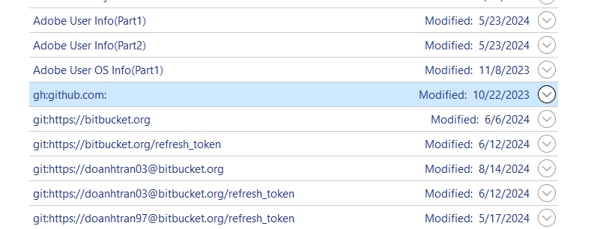

Delete this entry by click on drop down button -> Click Remove

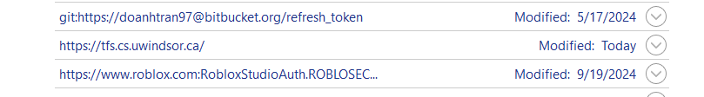

**Do the same with this one.**

### Change git Configuration

git config --global credential.helper manager

git config --global user.name "YourNewUsername"

git config --global user.email "yournewemail@example.com"

**Change here accordingly to your Credential.**

## Let get started setting up the project

### Connect to CS AzureDevops server

In Visual Studio Code -> View -> Team Explorer

**Click on the Connect button here.**

**Click on the Manage Connections.**

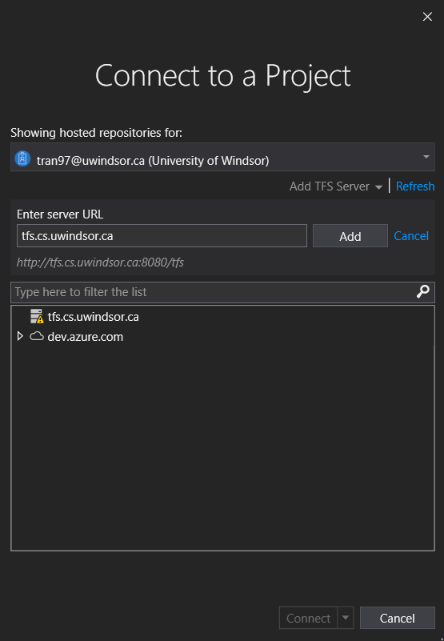  
NOTE: It could be frustrating caused by network error showing up, you could ignore it and continue to spam server URL and Add. Please close Visual Studio and refresh Global Protect if it insists in giving you error.

**Type in sever URL.**

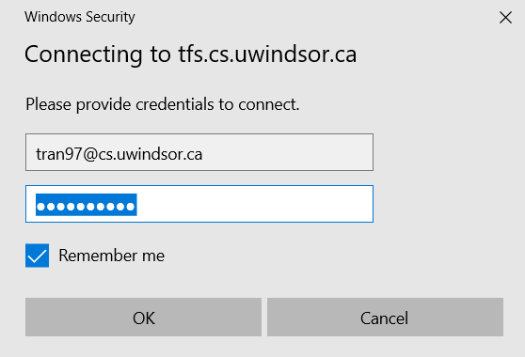

**Password is your synced password, if it does not work -> please try your previous ones.**

**Type in your uwindsor id followed by @cs.uwindsor.ca.**

**Congratulations, you have connected to our project in server.**

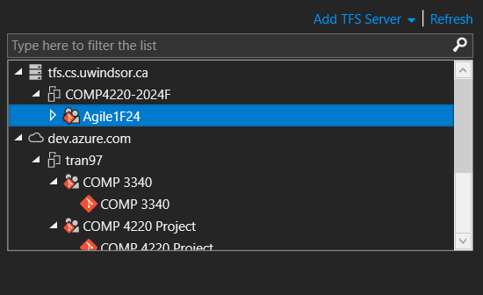

Click on Clone project -> Choose Directory and Save (Please save the local URL somewhere to use it later). In my cases, I have cloned it.

**Double click on the solution here to allow panes show up.**

### Connect to CS AzureDevops Database

On View -> Server Explorer.

**Click on Add Database button**

**Click on Change -> Microsoft SQL Server -> OK**

**Enter Username, Password**

**Enter server name**

**Congratulation, you have connected to the server successfully if you see this.**

## Setting Git on local machine

When you cloned the project to your machine, it comes with .git files that allows you to manage git of the project.  
On your computer -> Search -> PowerShell.

**Here is our solution**

To checkout your branch, run **git branch -a** and **git checkout [your uwindsor id]**

**Check if your branch has been created on upstream**

**Check if your branch has been created. If not, please contact me.**

## Additional Knowledge

### How to set up Team Foundation Server

Do you know you could set up a Team Foundation Server on your own machine?  
Try the following method

**Prerequisite:**   
+ TFS installation file (I will not attach specific link here, please search the newest on Internet)  
+ Window operating system (did not expect it runs on Mac since its Microsoft product :D). Team Foundation Server runs on both Window Home and Window Server.

**TFS set up:**  
<https://www.youtube.com/watch?v=rgf0IgktMQU>

The TFS installation file is downloaded

Figure 1: Installation file downloaded.

The Deployment Wizard is used

Figure 2: Option 1 in Deployment Wizard is chosen for the deployment.

The SQL Server Express instance will be installed to store the project collection

Figure 3: Installation of SQL Server Express, which is used to store team project collection.